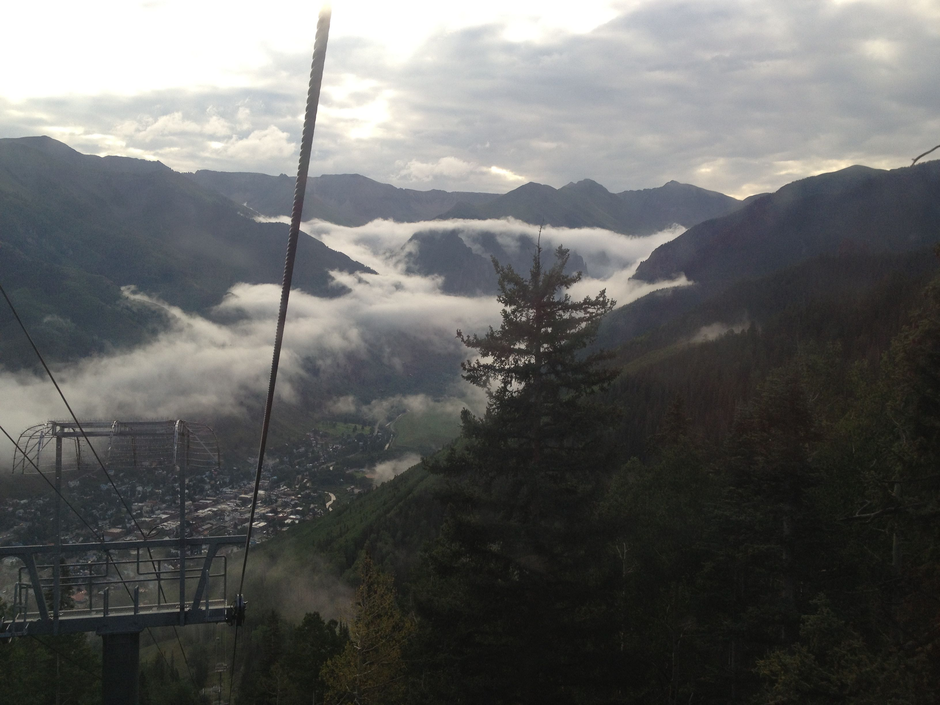
Accelerating Reaction Discovery Workshop
DRAFT SCHEDULE
Telluride Science Research Center (Virtual)
July 27-31, 2020

Time | Monday  7/27 | Tuesday  7/28 | Wednesday  7/29 | Thursday  7/30 | Friday  7/31
2:00-2:40 | Dean Tantillo | Peng Liu | Sarah Wengryniuk | Sidney Wilkerson-Hill | Croix Laconsay (Tantillo),  Student
2:40-3:00 | Student | Satam, Nishikant  (O’Doherty) | Xiaotian Qi  (Liu) | Student | Eric Deihl  (Brummond)
3:00-3:20 | Break | Break | Break | Break | Break
3:20-4:00 | Joseph Badillo | Matt McIntosh | George O’Doherty | Kay Brummond | Dan Dempe  (Brummond),  Student
4:00-4:20 | Ilia Kevlishvili  (Liu) | Joe Burchick  (Brummond) | Amy Merrill (Tantillo) | Binh Mai  (Liu) | Joe Winkelbauer  (Brummond)
4:20-4:30 | Closing Remarks | Closing Remarks | Closing Remarks | Closing Remarks | Closing  Remarks

All times are listed in Eastern Standard Time
Faculty time slots include 20 min presentation, 20 min Q&A
Student time slots include 10 min presentation, 10 min Q&A

